A F&B manager wants to determine whether there is any significant difference in the diameter of the cutlet between two units. A randomly selected sample of cutlets was collected from both units and measured? Analyze the data and draw inferences at 5% significance level. Please state the assumptions and tests that you carried out to check validity of the assumptions.

Sol.

Assumption:

Null Hypothesis : Mean of difference in the diameter of the cutlet between two units are same.

Alternate Hypothesis : Not same.

Confidence : 95.0

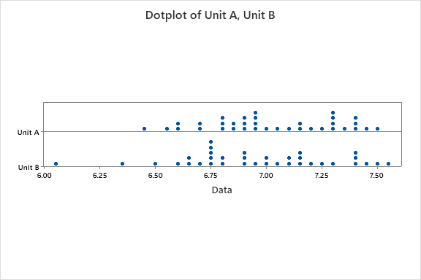

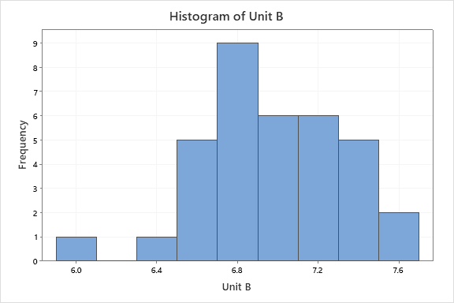

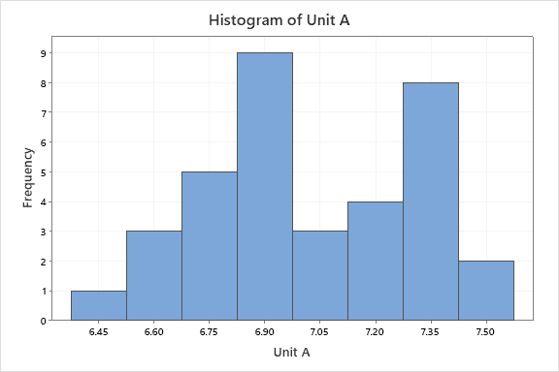

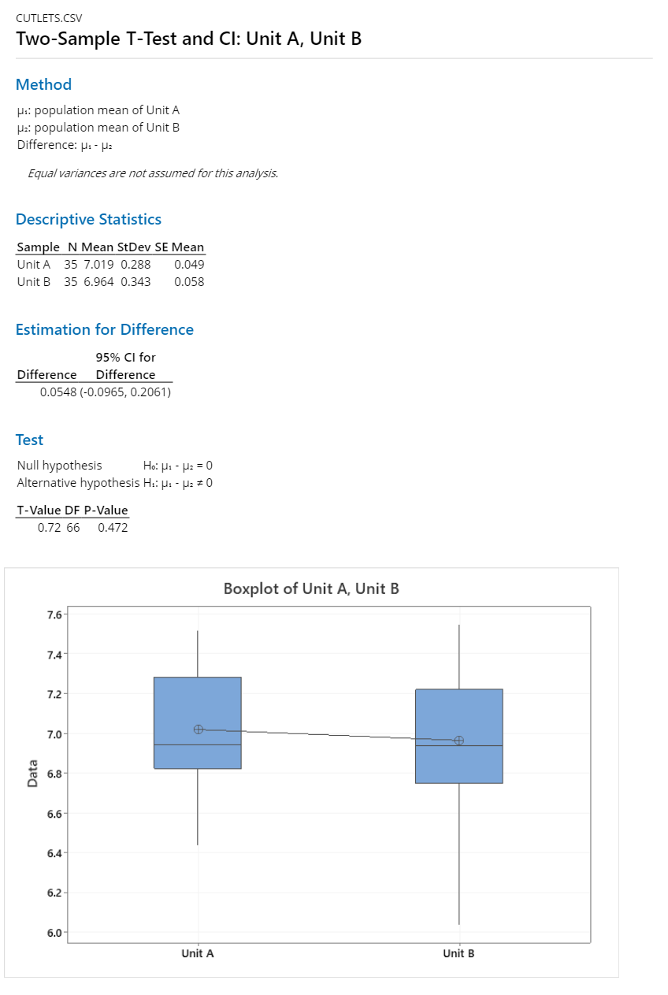

Here the P-value is greater then 5%. We will accept the null hypothesis.